Group 17

Project 1

Computer Science 313

Members:
Ryan Allen  Student Email: 26221527@sun.ac.za | Courtney Campbell  Student Email: 27906124@sun.ac.za | Erin Painting  Student Email: 27023931@sun.ac.za | Kayla De Beer  Student Email: 27480216@sun.ac.za
Role: Server | Role: Client | Role: Client | Role: Server
Server.java  Experiment 1  Experiment 2 | Client.java  LoginController.java  ChatApp.java  Login.fxml  Experiment 1  Experiment 2 | ChatApp.java  client.java  ChatController.java  ChatUI.fxml  Message.java  All README.md’s  Makefile | Server.java  Experiment 3

1. Introduction / Overview
This project involved building a client–server chat application that allows multiple users to communicate in real time over a network. The system follows a single-server, multiple-client model, where one central server manages all client connections and forwards messages between users. The chat application supports both global messages, which are visible to all connected users, and private whisper messages exchanged between two users. Tailscale was used to enable the server and clients to connect across different machines through a virtual network.
As a group, the work was divided so that two members focused on the server implementation while the other two worked on the client-side networking. A shared Message class was created early in development to ensure a consistent communication format across all components. In addition, a Client class was implemented to handle connections to the server, while a Server class managed the networking responsibilities and client communication.

2. AI Declaration
- Gemini – Helped with the structure and skeleton for part of the client file.
- Claude – Assisted in fixing compilation errors and understanding where to locate problems in the code.
- ChatGPT – Edited the report document for language and grammar corrections.
- ChatGPT – Explained and guided us on how to correctly run both the client and server using Tailscale, including configuring IP addresses, ensuring both machines were on the same virtual network, and troubleshooting connection issues.
- Gemini – Helped create test scripts used during experimentation.
- ChatGPT – Assisted with styling of code and comments to ensure consistency.
- ChatGPT – Helped format and edit all the README files.
- Claude – Assisted in creating the Makefile.
- ChatGPT – Helped clarify networking concepts related to sockets and multithreading when implementing the client–server communication.
- ChatGPT – Helped implement message serialization in the Message class so that objects could be sent over the network correctly.

3. Experiments
The report must detail three experiments, where each experiment follows the scientific method.
Each experiment requires a question and/or hypothesis, methods to test the hypothesis, a visualisation of the results, and a conclusion.
• Your data must be collected and displayed using a graph or a table. Label your data such that your independent and dependent variables are clearly visible.
• The methods of your experiment must be reproducible. You may be asked to perform 1 of the 3 experiments during the demo as proof that experiments are valid.

- How long does message delivery take depending on the number of bits sent?
  - Variables:
- Dependent: Message delivery time in seconds
- Independent: Length of message in bits
  - Hypothesis: Message delivery time and message length will have a direct relationship – the longer the message length is, the longer the message delivery will be.
  - Tests: Single client sends 5 messages, with message length doubling each time. Use System.nanotime() for start and end time of operation.
  - Visualization of results: Length-Time graph with 5 points plotted and line of best fit.

Message number | 1 | 2 | 3 | 4 | 5
Bits | 8000 | 16000 | 32000 | 64000 | 128000
Characters | 1000 | 2000 | 4000 | 8000 | 16000
RTT (nanoseconds) | 83267000 | 42899000 | 44948000 | 46807000 | 53222000

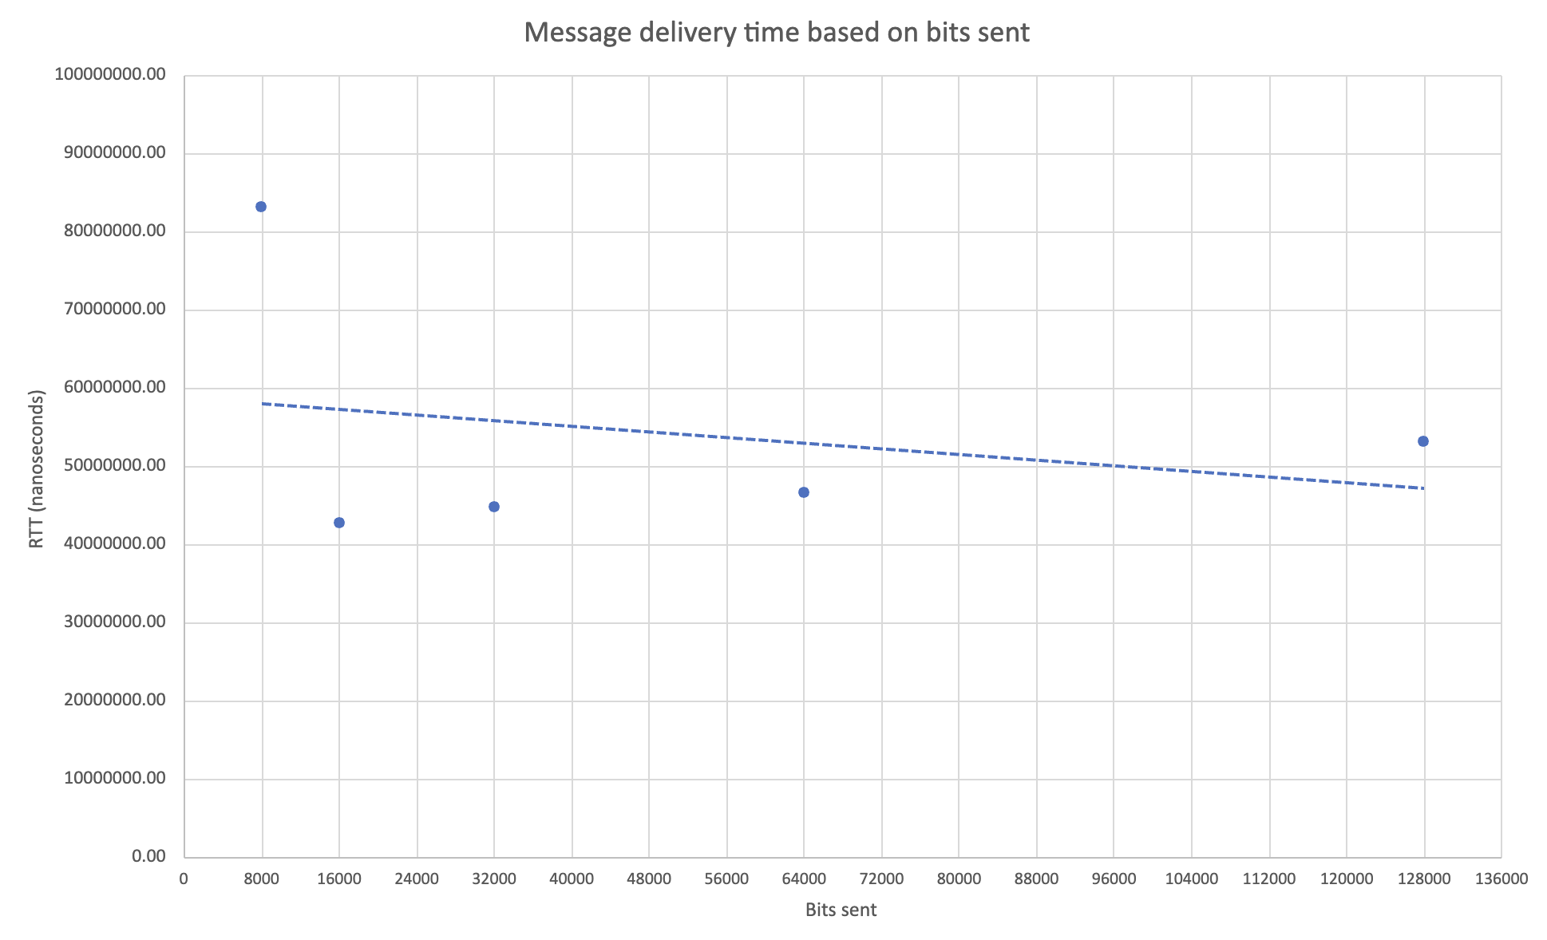

  - Conclusion: Although there is some growth in time for longer messages, it is not proportional to the doubling of message size. This indicates that message length does play a role in the delivery time, but it is not the dominant factor. The results suggest that the dominant factor in delivery time may be connection setup time, processing time, or network latency. Therefore, the hypothesis is partially supported; however, the correlation between message length and delivery time is weak.

- How many clients can connect to the server?
  - Variables:
- Dependent: maximum number of connected clients before server crash
- Independent: number of connected clients
  - Hypothesis: The theoretical limit is very high, but the actual limit can only be determined by testing due to limiting factors such as hardware limitations.
  - Tests: Connect clients until server crashes or other error occurs, counting the maximum number of connected clients. Repeat experiment 3 times to see if limit changes.
  - Visualization of results: Table having maximum number of clients before error for all 3 trials.

Trial number | Clients connected successfully before failure | Reason for failure
1 | 18728 | OS socket limit
2 | 18728 | OS socket limit
3 | 18728 | OS socket limit

  - Conclusion: After testing, it can be said that the maximum capacity for the server is 18728 clients. The server eventually crashes on the connection of the 18729th client due to the OS socket limits.

- How does the number of concurrent messages affect the speed of message delivery?
  - Variables:
- Dependent: Latency
- Independent: Number of concurrent messages
- Constant: Number of clients (5)
  - Hypothesis: Number of concurrent messages and latency will have a direct relationship – the more concurrent messages, the longer the latency.
  - Tests: Send 1-5 messages simultaneously, use System.nanotime() to measure time taken. It is important to keep the number of clients consistent.
  - Visualization of results: Frequency-latency table. Scatter plot with line of best fit. Note that the data with only one message sent has been identified as an outlier.

No. Concurrent Messages | Latency (ms)
1 | 7.407320
2 | 1.052898
3 | 1.450406
4 | 1.817498
5 | 1.921442

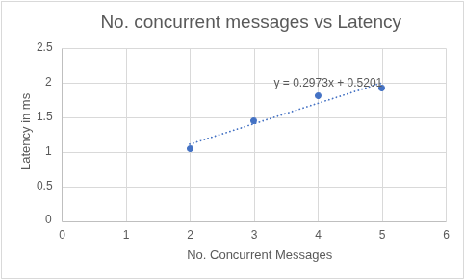

  - Conclusion: The results confirm the direct relationship between the number of concurrent messages sent and the latency, as hypothesized. The first message has been excluded as an outlier due to a consistently high latency measurement, presumably having to do with the setup of the test method.

